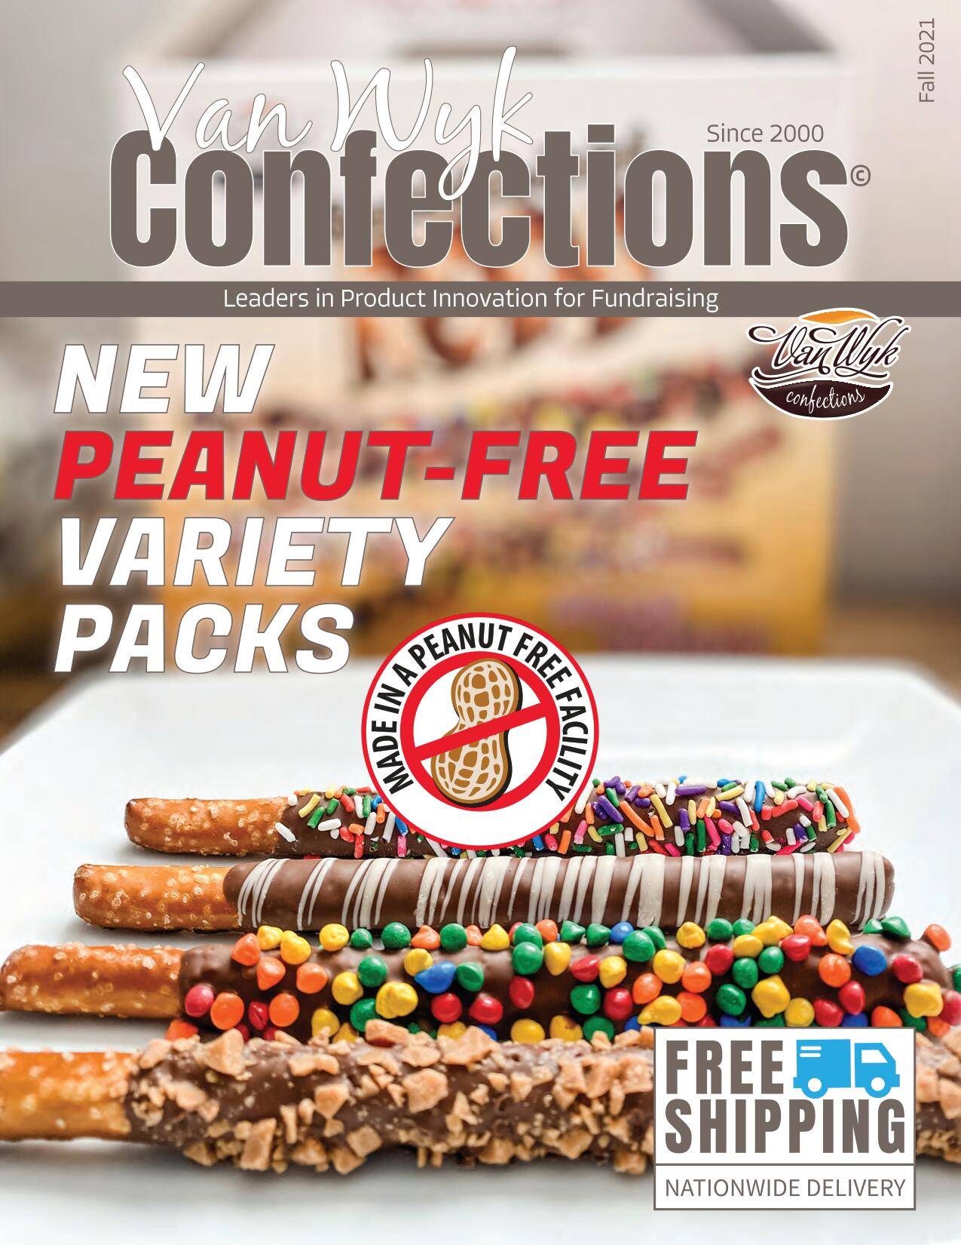

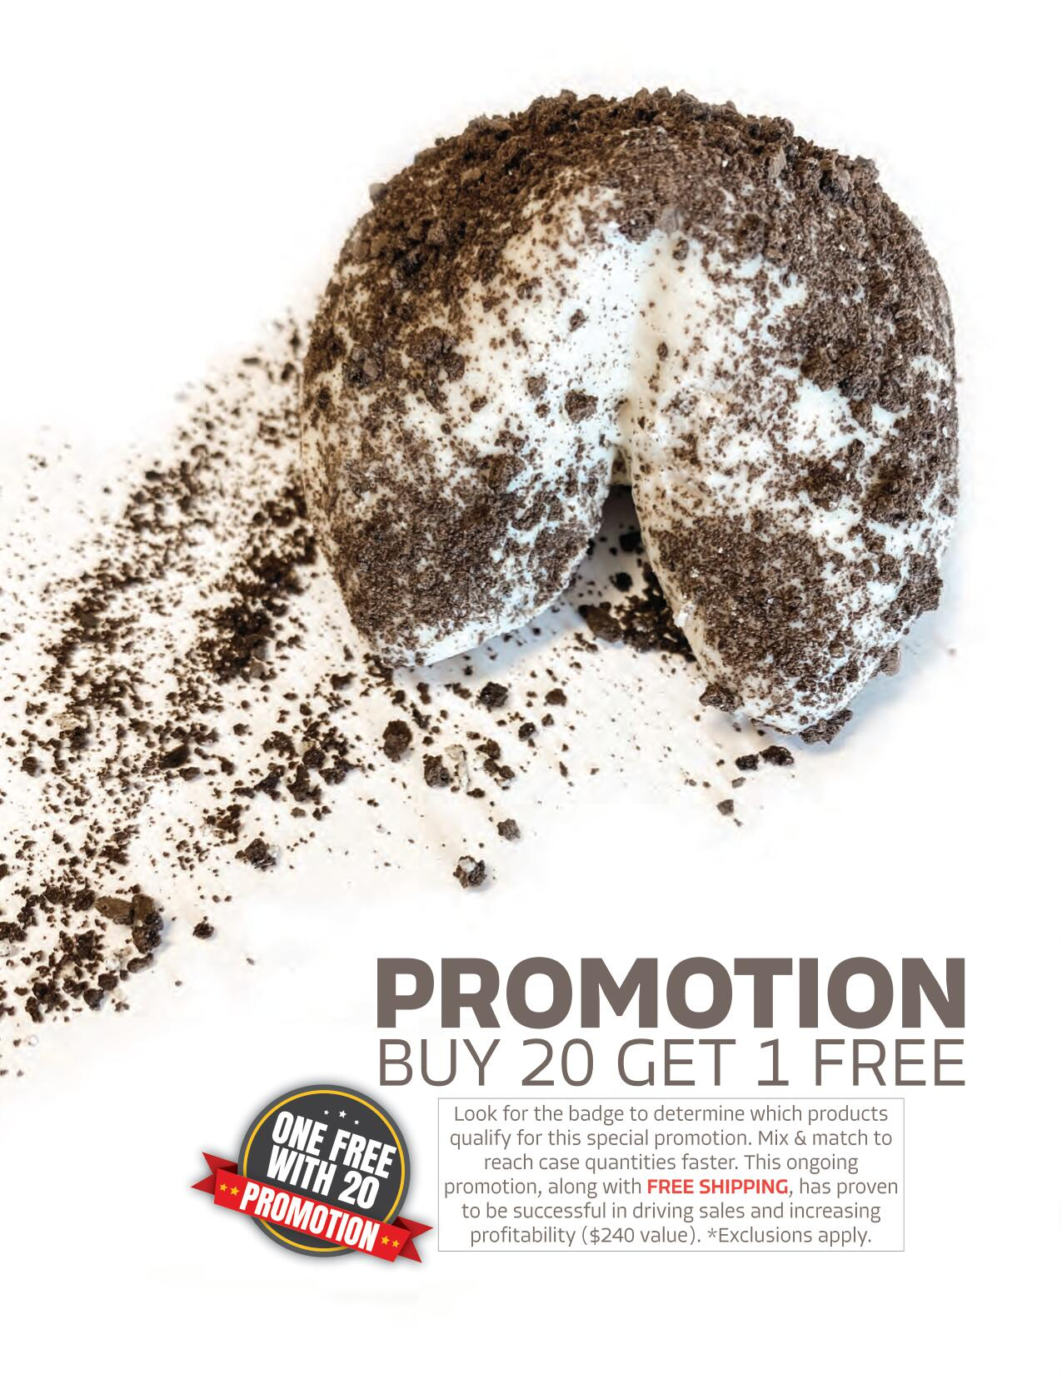

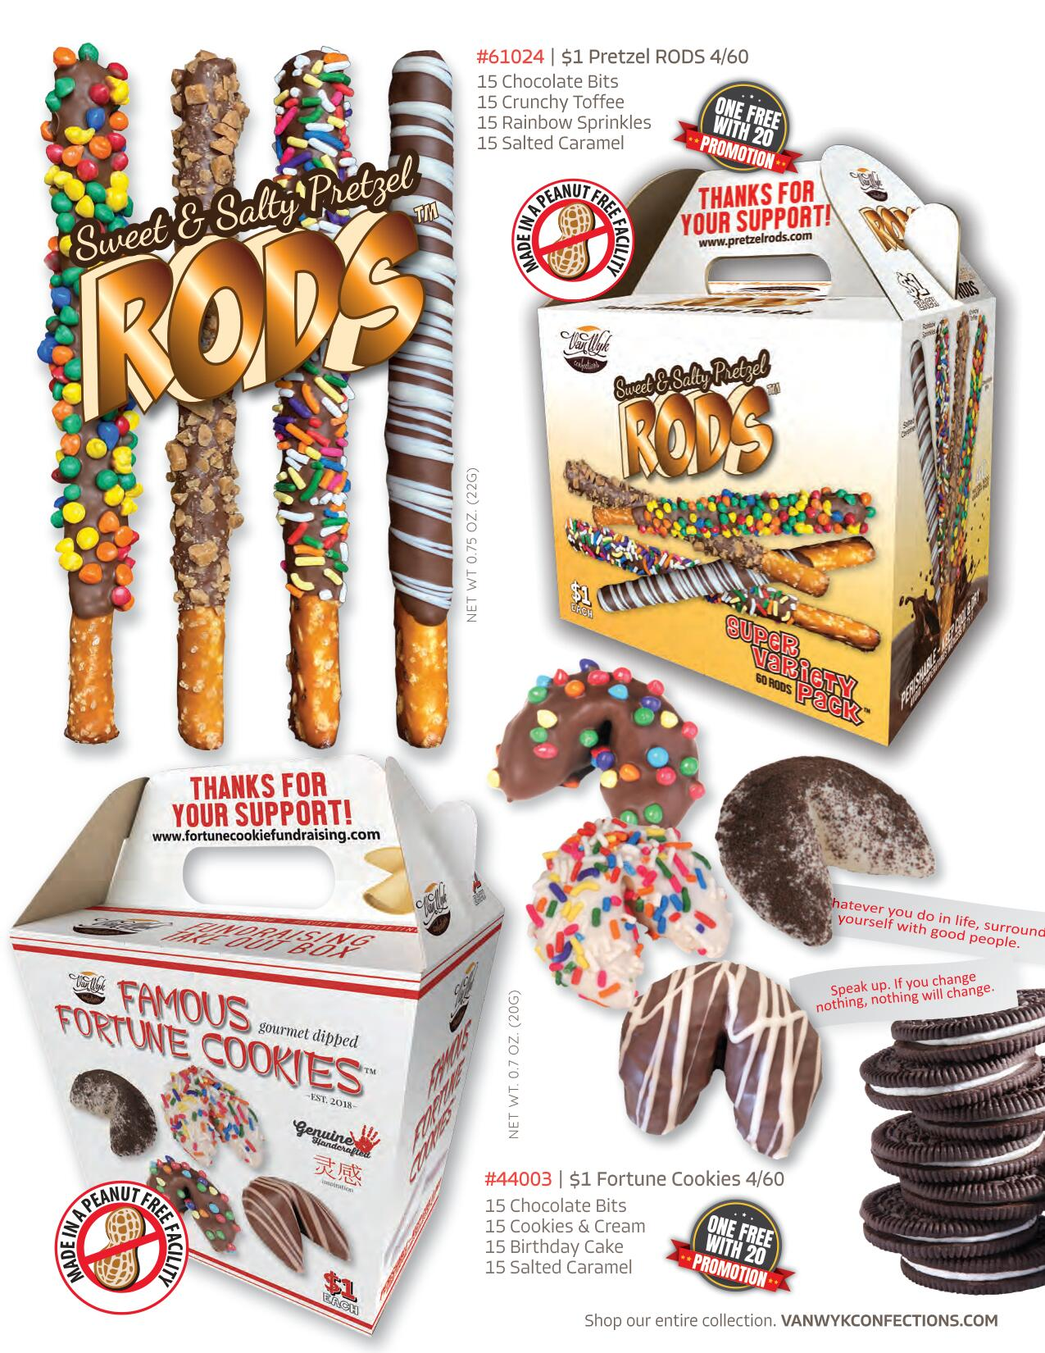

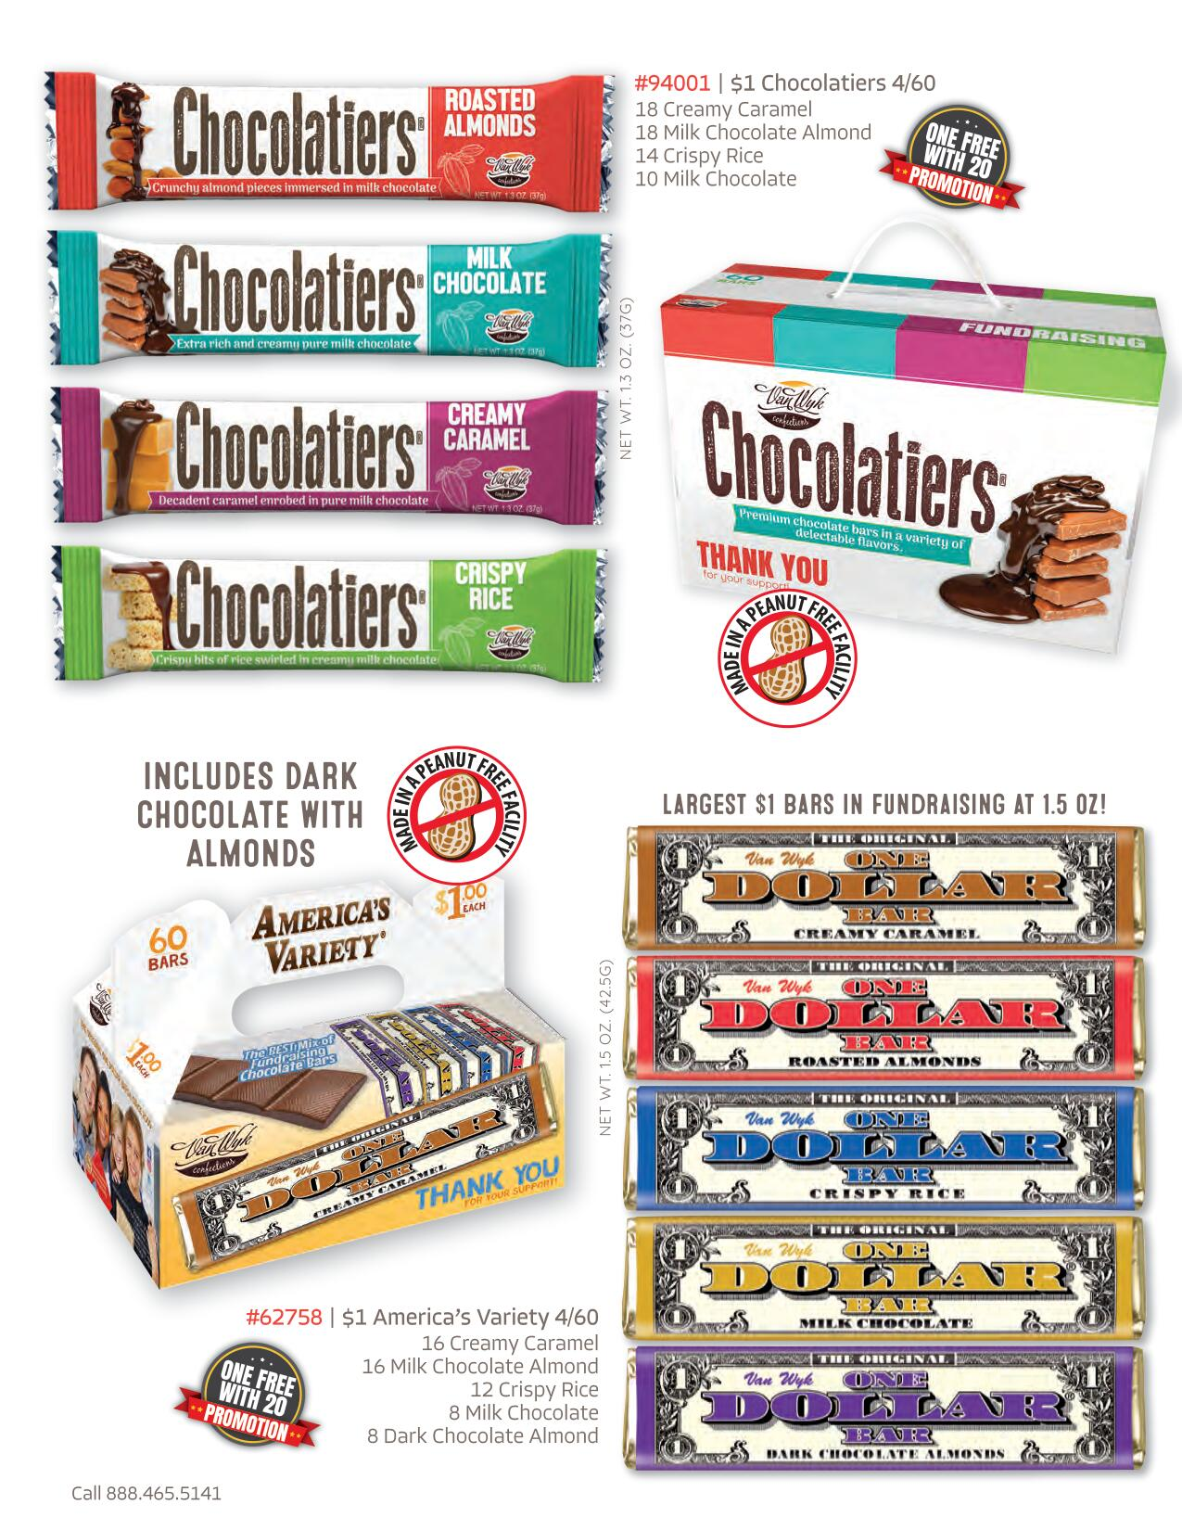

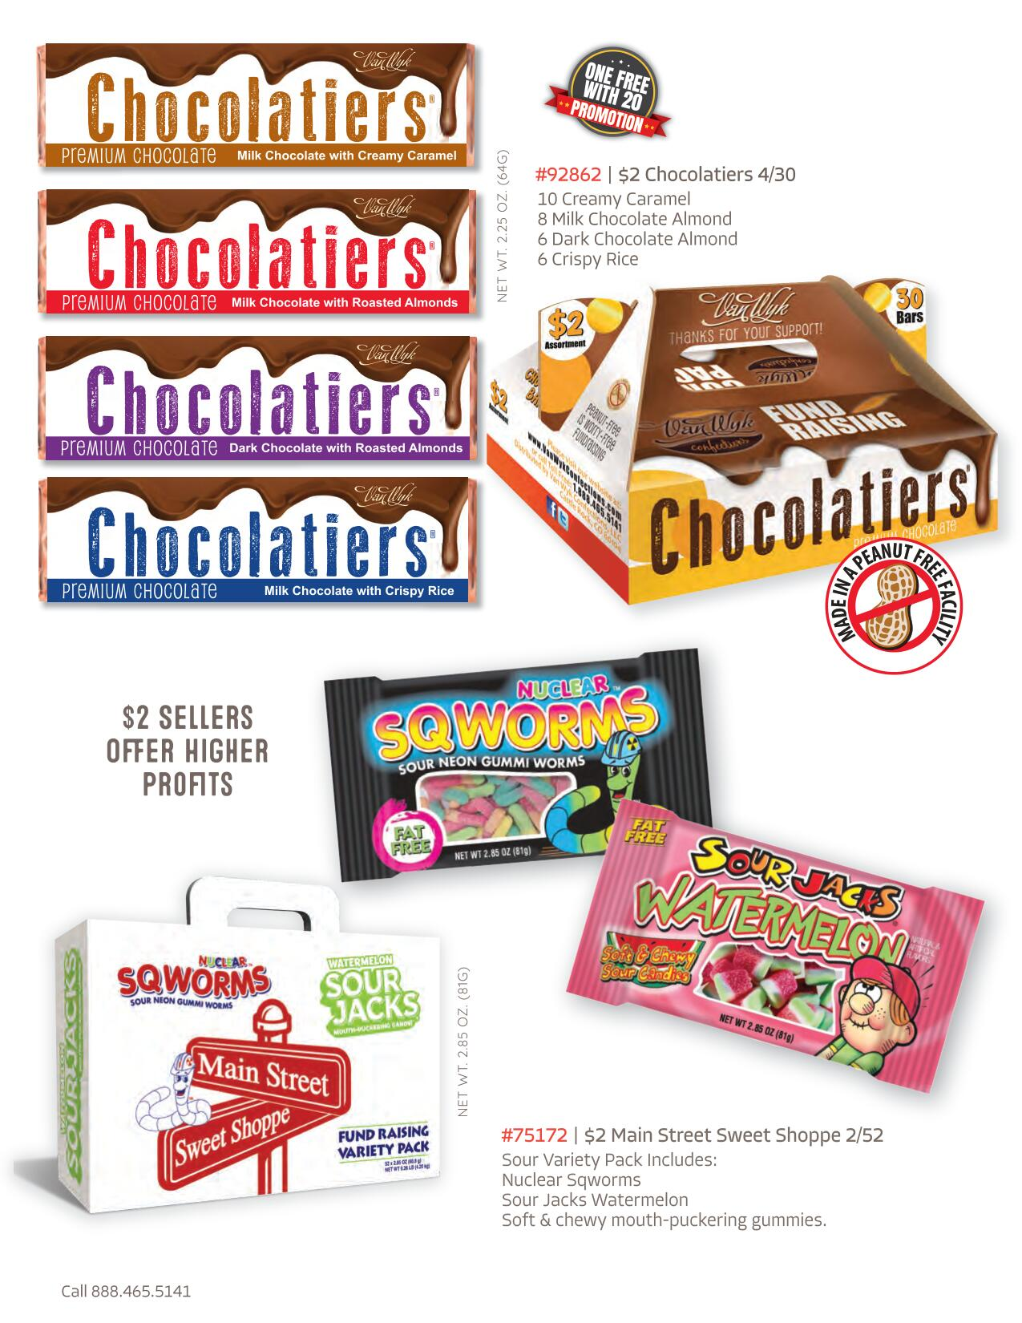

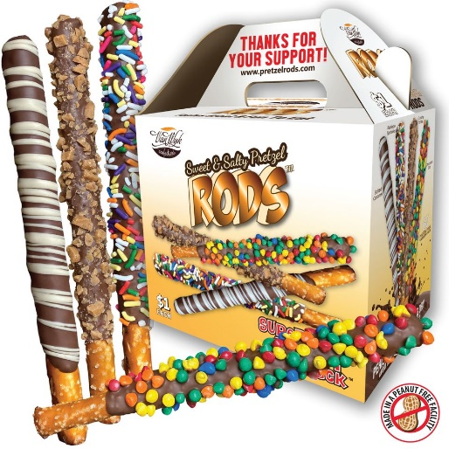 | $1 Van Wyk Chocolate-Dipped Pretzel Rods Fundraiser  Salty & Sweet Pretzel Rods are one of our top-selling items. If you and your supporters are craving something salty and sweet, Van Wyk Pretzel Rods will satisfy your craving! Individually wrapped, the pretzel rods are available in four delectable flavors! They are wonderful for school stores, after-school snacks, Halloween treats, Christmas stocking stuffers, and sharing with friends!  4 (60) count variety carriers per case  240 chocolate-dipped pretzel rods per case  15 Chocolate Bits  15 Crunchy Toffee  15 Rainbow Sprinkles  15 Salted Caramel
$1.00 Sellers  Cost: $96 per case  Profit: 60% | Purchase 1-19 cases - Cost: $144 each, Profit: $96 each, Percent: 40%  Purchase 20-39 cases - Cost: $137 each, Profit: $103 each, Percent: 43%  Purchase 40-59 cases - Cost: $132 each, Profit: $108 each, Percent: 45%  Purchase 60+ cases - Cost: $120 each, Profit $120 each, Percent: 50%
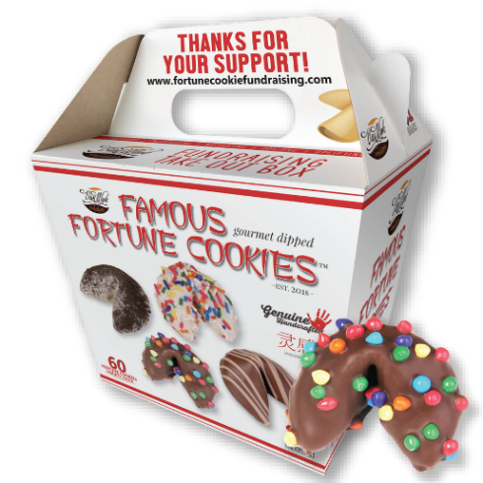 | $1 Van Wyk Famous Fortune Cookies Fundraiser  Who can resist the fun in opening a chocolate-covered fortune cookie? Van Wyk Famous Fortune Cookies are truly unique and such a fun fundraiser! Each cookie has an inspirational and encouraging message inside that's perfect for kids! Irresistible, kids and adults alike will have fun with these cookies. And of course, they will want to purchase many!  4 (60) count variety carriers per case  240 chocolate-dipped fortune cookies per case  15 Chocolate Bits  15 Cookies & Cream  15 Birthday Cake  15 Salted Caramel
$1.00 Sellers  Cost: $96 per case  Profit 60% | Purchase 1-19 cases - Cost: $144 each, Profit: $96 each, Percent: 40%  Purchase 20-39 cases - Cost: $137 each, Profit: $103 each, Percent: 43%  Purchase 40-59 cases - Cost: $132 each, Profit: $108 each, Percent: 45%  Purchase 60+ cases - Cost: $120 each, Profit $120 each, Percent: 50%
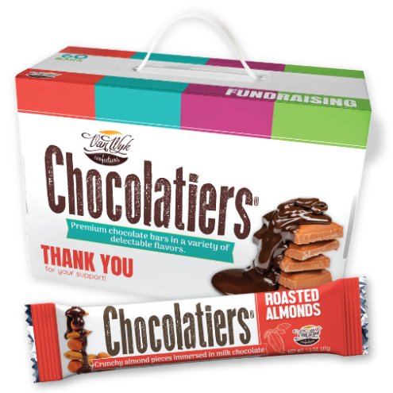 | $1 Van Wyk Chocolatiers Candy Bar Fundraiser  Our Chocolatiers Variety Pack is a great option for organizations searching for a peanut-free, gluten-free, and Kosher candy bar fundraiser! Our chocolate bar variety pack offers 4 milk chocolate flavors (1.5 oz. each) that are absolutely fabulous. You'll want to try one of each!  4 (60) count variety carriers per case  240 chocolate bars per case  18 Creamy Caramel  18 Milk Chocolate Almond  14 Crispy Rice  10 Milk Chocolate
$1.00+ Sellers  Cost: $96 per case  Profit: 60% | Purchase 1-19 cases - Cost: $144 each, Profit: $96 each, Percent: 40%  Purchase 20-39 cases - Cost: $137 each, Profit: $103 each, Percent: 43%  Purchase 40-59 cases - Cost: $132 each, Profit: $108 each, Percent: 45%  Purchase 60+ cases - Cost: $120 each, Profit $120 each, Percent: 50%
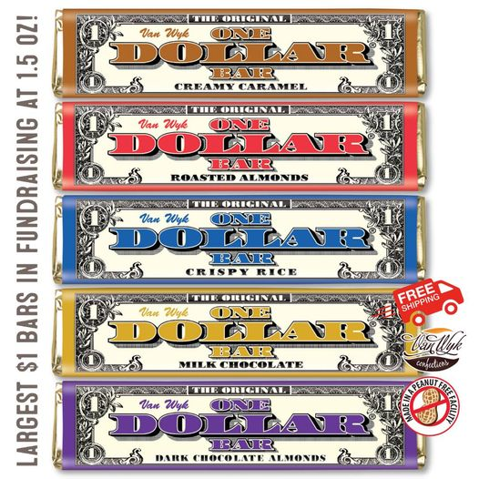 | Van Wyk America’s Variety Pack Chocolate Bar Fundraiser  For over 20 years Van Wyk Confectioners has helped organizations raise money with the original one-dollar chocolate bar! Premium in quality, America's Variety One Dollar Bars offers 5 tasty flavors including dark chocolate with almonds bar. Oh, and they are peanut-free and gluten-free! Just wait until you try them!  4 (60) count variety carriers per case  240 chocolate bars per case  16 Creamy Caramel  16 Milk Chocolate Almond  12 Crispy Rice  8 Milk Chocolate  8 Dark Chocolate Almond
$1.00 Sellers  Cost: $96 per case  Profit to 60% | Purchase 1-19 cases - Cost: $144 each, Profit: $96 each, Percent: 40%  Purchase 20-39 cases - Cost: $137 each, Profit: $103 each, Percent: 43%  Purchase 40-59 cases - Cost: $132 each, Profit: $108 each, Percent: 45%  Purchase 60+ - Cost: $120 each, Profit $120 each, Percent: 50%
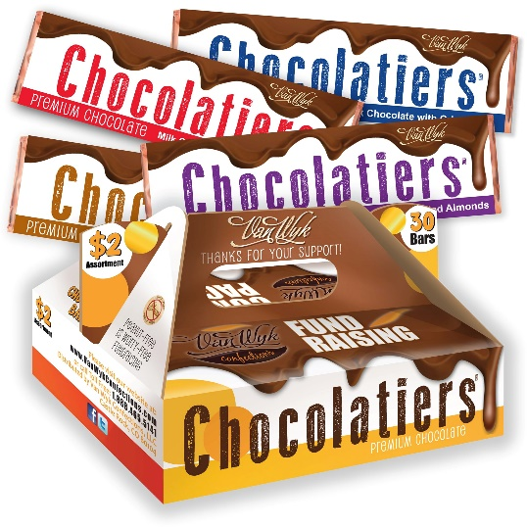 | $2 Van Wyk Large Chocolatiers Chocolate Bars Fundraiser  Are you looking to really satisfy your chocolate craving?! The very big, 2.25 oz. Van Wyk Chocolatier Chocolate Bars are the answer! With four delicious chocolate bar flavors, including dark chocolate, they are certified peanut-free, gluten-free, and Kosher.  4 (30) count variety carriers per case  120 Van Wyk Chocolatier bars per case  10 Creamy Caramel  8 Milk Chocolate Almond  6 Dark Chocolate Almond  6 crispy Rice
$2.00 Sellers  Cost: $120-$144 per case  Profit: 40%-50% | Purchase 1-19 cases - Cost: $144 each, Profit: $96 each, Percent: 40%  Purchase 20-39 cases - Cost: $137 each, Profit: $103 each, Percent: 43%  Purchase 40-59 cases - Cost: $132 each, Profit: $108 each, Percent: 45%  Purchase 60+ cases - Cost: $120 each, Profit $120 each, Percent: 50%
Mix and Match:

One Free with 20 Promotion:

Shipping: FREE SHIPPING on ALL $1 and $2 sellers when temperatures are below 76 degrees Fahrenheit. (Dry ice and refrigerated shipping is an additional cost when temperatures rise above 76 degrees. Best Fundraising Ideas will pay half the shipping cost if applied. Purchase 1-9 cases: $10 per case
10-19 Cases: $5 per case
20-59 Cases: $50 flat fee
60+ Cases: FREE SHIPPING

